H.T No
Regulations:
A17

Sreenidhi Institute of Science and Technology
(An Autonomous Institution)
Code No: 6K502 Date: 20-Mar-2021(FN)

B.Tech III-Year I- Semester External Examination, March/April - 2021 (Supplementary)
Structural Analysis - II (CIVIL)

Time: 3 Hours Max.Marks:75

Note: a) No additional answer sheets will be provided.
b) All sub-parts of a question must be answered at one place only, otherwise it will not be valued.
c) Missing data can be assumed suitably.

ANSWER ANY 5 OUT OF 8 QUESTIONS. EACH QUESTION CARRIES 15 MARKS.

Bloom's Cognitive Levels of Learning (BCLL)

Remember | L1 | Apply | L3 | Evaluate | L5
Understand | L2 | Analyze | L4 | Create | L6

 |  |  | BCLL | CO(s) | Marks
1. |  | Draw the ILD for shear force and bending moment for a section at 5 m from the left hand support of a simply supported beam, 20 m long. Hence, calculate the maximum bending moment and shear force at the section, due to a uniformly distributed rolling load of length 8 m and intensity 10 kN/m run. | L4 | CO1 | [15M]
2. | a) | A three hinged parabolic arch of span 32 m with a central rise of 8m carries a uniformly distributed load of 20kN/m over the right half portion, and also carries two concentrated loads of 40kN and 60kN at a distance of 6m and 12m from the left support. Determine the bending moment, thrust at a distance of 12m from the left support. | L3 | CO2 | [8M]
 | b) | A two hinged circular segmental arch of span 80m and rise 10m carries a point load 100kN at a distance of 20m from left support together with a UDL 40kN/m over the right half of the span. Determine the reactions at the supports and also find the internal forces at 20m from the right support. | L4 | CO2 | [7M]
3. |  | A cable of suspension bridge of span 100m hangs between two points at the same level. It carries a horizontal UDL of 1kN/m over the entire span. The dip of the cable is 20m and the slope of the anchorage cable at the top of the tower is 300 with the horizontal. Determine the horizontal and vertical reaction at the towers if the cable passes over a pulley. | L4 | CO3 | [15M]
4. |  | Analyze the continuous beam shown in fig. using flexibility method  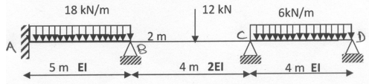 | L4 | CO4 | [15M]
5. |  | Analyze the continuous beam by stiffness method? Assume EI is constant. Draw B.M.D.  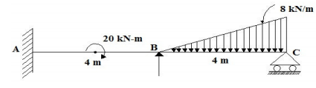 | L4 | CO5 | [15M]
6. | a) | Describe the Moment-Curvature relationship in plastic analysis. | L3 | CO6 | [8M]
 | b) | Explain the following terms; with reference to plastic analysis  (i) plastic section modulus (ZP) (ii) shape factor (s) (iii) plastic moment (Mp) | L2 | CO6 | [7M]
7. | a) | Two point loads of 8kN and 10kN spaced 10m apart across a girder of 20m span, the 8kN load loading from left to right. Construct the S.F and B.M diagrams stating the absolute maximum values. | L3 | CO1 | [8M]
 | b) | A cable supported at the same level on either end is of 140m horizontal span with a central dip of 14m. It carries a load of 15kN/m on its horizontal span. Calculate the change in the horizontal tension when the temperature rises through 28°C. Coefficient of linear expansion of the cable material is 4x10-6 /°C. | L3 | CO2 | [7M]
8. | a) | Analyse the Continuous beam shown in figure using flexibility method. Sketch the BMD & SFD. EI is constant.  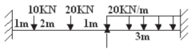 | L3 | CO4 | [8M]
 | b) | Briefly explain the three basic theorems on which plastic analysis has been developed. | L3 | CO5 | [7M]

-- 00 -- 00 –

